# **PYTHON STRINGS**

**Intro:**

A String is a data structure in Python that represents a sequence of characters. It is an immutable data type, meaning that once you have created a string, you cannot change it. Strings are used widely in many different applications, such as storing and manipulating text data, representing names, addresses, and other types of data that can be represented as text.

**Creating a String in Python**

**Strings in Python** can be created using single quotes or double quotes or even triple quotes. Let us see how we can define a string in Python.We will demonstrate different ways to create a Python String. We will create a string using single quotes (‘ ‘), double quotes (” “), and triple double quotes (“”” “””). The triple quotes can be used to declare multiline strings in Python.

EG:

a = "Hello"  
print(a)

#MULTILINE STRING

a = """Hello World

Welcome to Python"""  
print(a)

**Accessing characters in Python String**

Indexing allows negative address references In Python, individual characters of a String can be accessed by using the method of Indexing. to access characters from the back of the String, e.g. -1 refers to the last character, -2 refers to the second last character, and so on.

While accessing an index out of the range will cause an **IndexError**. Only Integers are allowed to be passed as an index, float or other types that will cause a **TypeError**.

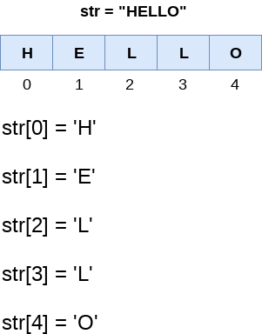

**String Slicing**

In Python, the String Slicing method is used to access a range of characters in the String. Slicing in a String is done by using a Slicing operator, i.e., a colon (:).  One thing to keep in mind while using this method is that the string returned after slicing includes the character at the start index but not the character at the last index.

The slice operator [] is used to access the individual characters of the string. However, we can use the : (colon) operator in Python to access the substring from the given string. Consider the following example.

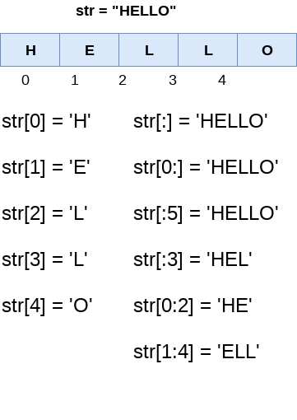

**Negative Indexing**

We can do the negative slicing in the string; it starts from the rightmost character, which is indicated as -1. The second rightmost index indicates -2, and so on. Consider the following image.

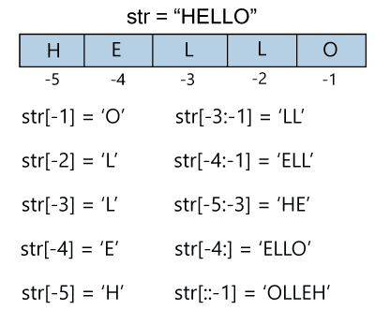

**String Methods**

Python has a set of built-in methods that you can use on strings.

|  |  |
| --- | --- |
| **Method** | **Description** |
| [capitalize()](https://www.w3schools.com/python/ref_string_capitalize.asp) | Converts the first character to upper case |
| [casefold()](https://www.w3schools.com/python/ref_string_casefold.asp) | Converts string into lower case |
| [center()](https://www.w3schools.com/python/ref_string_center.asp) | Returns a centered string |
| [count()](https://www.w3schools.com/python/ref_string_count.asp) | Returns the number of times a specified value occurs in a string |
| [endswith()](https://www.w3schools.com/python/ref_string_endswith.asp) | Returns true if the string ends with the specified value |
| [find()](https://www.w3schools.com/python/ref_string_find.asp) | Searches the string for a specified value and returns the position of where  it was found |
| [format()](https://www.w3schools.com/python/ref_string_format.asp) | Formats specified values in a string |
| [index()](https://www.w3schools.com/python/ref_string_index.asp) | Searches the string for a specified value and returns the position of where  it was found |
| [isalnum()](https://www.w3schools.com/python/ref_string_isalnum.asp) | Returns True if all characters in the string are alphanumeric |
| [isalpha()](https://www.w3schools.com/python/ref_string_isalpha.asp) | Returns True if all characters in the string are in the alphabet |
| [isascii()](https://www.w3schools.com/python/ref_string_isascii.asp) | Returns True if all characters in the string are ascii characters |
| [isdecimal()](https://www.w3schools.com/python/ref_string_isdecimal.asp) | Returns True if all characters in the string are decimals |
| [isdigit()](https://www.w3schools.com/python/ref_string_isdigit.asp) | Returns True if all characters in the string are digits |
| [isidentifier()](https://www.w3schools.com/python/ref_string_isidentifier.asp) | Returns True if the string is an identifier |
| [islower()](https://www.w3schools.com/python/ref_string_islower.asp) | Returns True if all characters in the string are lower case |
| [isnumeric()](https://www.w3schools.com/python/ref_string_isnumeric.asp) | Returns True if all characters in the string are numeric |
| [istitle()](https://www.w3schools.com/python/ref_string_istitle.asp) | Returns True if the string follows the rules of a title |
| [isupper()](https://www.w3schools.com/python/ref_string_isupper.asp) | Returns True if all characters in the string are upper case |
| [join()](https://www.w3schools.com/python/ref_string_join.asp) | Joins the elements of an iterable to the end of the string |
| [lower()](https://www.w3schools.com/python/ref_string_lower.asp) | Converts a string into lower case |
| [lstrip()](https://www.w3schools.com/python/ref_string_lstrip.asp) | Returns a left trim version of the string |
| [replace()](https://www.w3schools.com/python/ref_string_replace.asp) | Returns a string where a specified value is replaced with a specified value |
| [split()](https://www.w3schools.com/python/ref_string_split.asp) | Splits the string at the specified separator, and returns a list |
| [startswith()](https://www.w3schools.com/python/ref_string_startswith.asp) | Returns true if the string starts with the specified value |
| [strip()](https://www.w3schools.com/python/ref_string_strip.asp) | Returns a trimmed version of the string |
| [swapcase()](https://www.w3schools.com/python/ref_string_swapcase.asp) | Swaps cases, lower case becomes upper case and vice versa |
| [title()](https://www.w3schools.com/python/ref_string_title.asp) | Converts the first character of each word to upper case |
| [translate()](https://www.w3schools.com/python/ref_string_translate.asp) | Returns a translated string |
| [upper()](https://www.w3schools.com/python/ref_string_upper.asp) | Converts a string into upper case |